**PIZZA SALES SQL QUERIES**

1. **KPIS**
2. Total revenue

select sum(total_price) as Total_Revenue from pizza_sales;

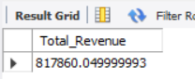

1. Average order value

select sum(total_price) / count(distinct(order_id)) as Average_order_value from pizza_sales;

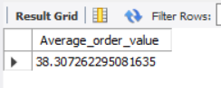

1. Total pizzas sold

select sum(quantity) from pizza_sales;

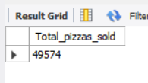

1. Total orders

select count(distinct(order_id)) from pizza_sales;

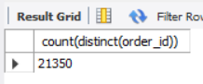

1. Average pizzas per order

select cast(cast(sum(quantity) AS decimal(10,2)) / cast(count(DISTINCT order_id) AS decimal(10,2)) AS decimal(10,2)) AS Avg_Pizzas_per_order from pizza_sales;

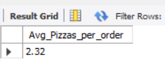

1. % of Sales by Pizza Category

SELECT pizza_category, CAST(SUM(total_price) AS DECIMAL(10,2)) as total_revenue,

CAST(SUM(total_price) * 100 / (SELECT SUM(total_price) from pizza_sales) AS DECIMAL(10,2)) AS PCT

FROM pizza_sales

GROUP BY pizza_category;

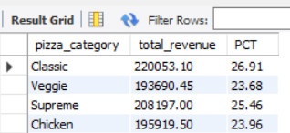

1. % of Sales by Pizza Size

SELECT pizza_size, CAST(SUM(total_price) AS DECIMAL(10,2)) as total_revenue,

CAST(SUM(total_price) * 100 / (SELECT SUM(total_price) from pizza_sales) AS DECIMAL(10,2)) AS PCT

FROM pizza_sales

GROUP BY pizza_size

ORDER BY pizza_size;

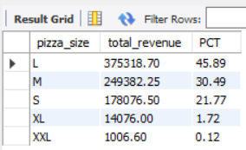

1. Total Pizzas Sold by Pizza Category

SELECT pizza_category, SUM(quantity) as Total_Quantity_Sold

FROM pizza_sales

WHERE MONTH(order_date) = 2

GROUP BY pizza_category

ORDER BY Total_Quantity_Sold DESC;

1. Top 5 Pizzas by Revenue

SELECT pizza_name, SUM(total_price) AS Total_Revenue

FROM pizza_sales

GROUP BY pizza_name

ORDER BY Total_Revenue DESC

limit 5;

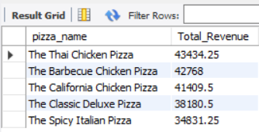

1. Bottom 5 Pizzas by Revenue

SELECT pizza_name, SUM(total_price) AS Total_Revenue

FROM pizza_sales

GROUP BY pizza_name

ORDER BY Total_Revenue ASC

limit 5;

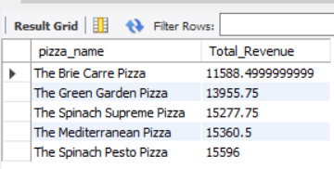

1. Top 5 Pizzas by Quantity

SELECT pizza_name, SUM(quantity) AS Total_Pizza_Sold

FROM pizza_sales

GROUP BY pizza_name

ORDER BY Total_Pizza_Sold DESC

limit 5;

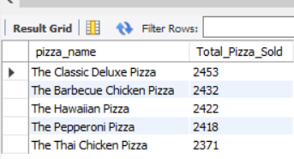

1. Bottom 5 Pizzas by Quantity

SELECT pizza_name, SUM(quantity) AS Total_Pizza_Sold

FROM pizza_sales

GROUP BY pizza_name

ORDER BY Total_Pizza_Sold ASC

limit 5;

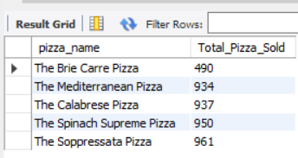

1. Top 5 Pizzas by Total Orders

SELECT pizza_name, COUNT(DISTINCT order_id) AS Total_Orders

FROM pizza_sales

GROUP BY pizza_name

ORDER BY Total_Orders DESC

limit 5;

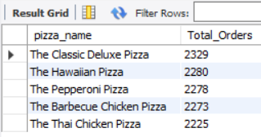

1. Bottom 5 Pizzas by Total Orders

SELECT pizza_name, COUNT(DISTINCT order_id) AS Total_Orders

FROM pizza_sales

GROUP BY pizza_name

ORDER BY Total_Orders ASC

limit 5;

